**DAILY ONLINE ACTIVITIES SUMMARY**

|  |  |  |  |  |  |  |  |  |
| --- | --- | --- | --- | --- | --- | --- | --- | --- |
| **Date:** | **19/07/2020** | | | | | **Name:** | **NAIPUNYA VINOD NAIK** | |
| **Sem & Sec** | **IV SEM & A SECTION** | | | | | **USN:** | **4AL18CS050** | |
| **Online Test Summary** | | | | | | | | |
| **Subject** | | **NO INTERNALS CONDUCTED** | | | | | | |
| **Max. Marks** | | **30** | | **Score** | | | **N/A** | |
| **Certification Course Summary** | | | | | | | | |
| **Course** | **1) THREAT PROTECTION AND APT ETHICAL HACKING COURSE**  **2) GUI PROGRAMMING AND CSV IN PYTHON BASICS(PROJECT ORIENTED)**  **3) LEARN AND UNDERSTAND BUFFER OVERFLOW FROM SCRATCH –BEGINNER**  **4) GOOGLE CLOUD PLATFORM BIG DATA AND MACHINE LEARNING FUNDAMENTALS** | | | | | | | |
| **Certificate Provider** | | | **1) UDEMY**  **2) UDEMY**  **3) UDEMY**  **4) COURSERA** | | **Duration** | | | **1) 30 MIN**  **2) 2 HRS**  **3) 35 MIN**  **4) 2 WEEKS** |
| **Coding Challenges** | | | | | | | | |
| **Problem Statement: Write a java program to check for string rotation.** | | | | | | | | |
| **Status: EXECUTED** | | | | | | | | |
| **Uploaded the report in Github** | | | | | **YES** | | | |
| **If yes Repository name** | | | | | <https://github.com/naipunya-naik/Online-Coding-platform-coding/blob/master/stringrotation_19-07-2020.java> | | | |
| **Uploaded the report in slack** | | | | | **YES** | | | |

Online Test Details: (Attach the snapshot and briefly write the report for the same).

NO INTERNALS CONDUCTED

Certification Course Details: (Attach the snapshot and briefly write the report for the same).

CERTIFICATION COURSE NAME:- **THREAT PROTECTION AND APT ETHICAL HACKING COURSE**

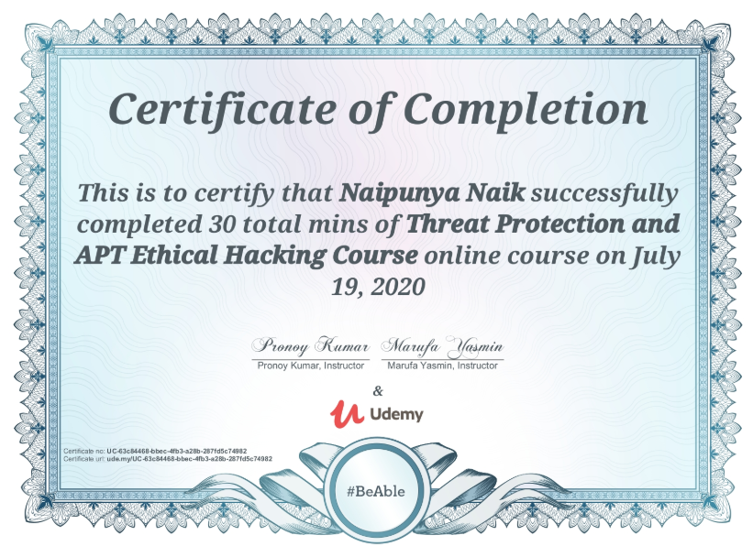

CERTIFICATION COURSE NAME:- **GUI PROGRAMMING AND CSV IN PYTHON BASICS(PROJECT ORIENTED).**

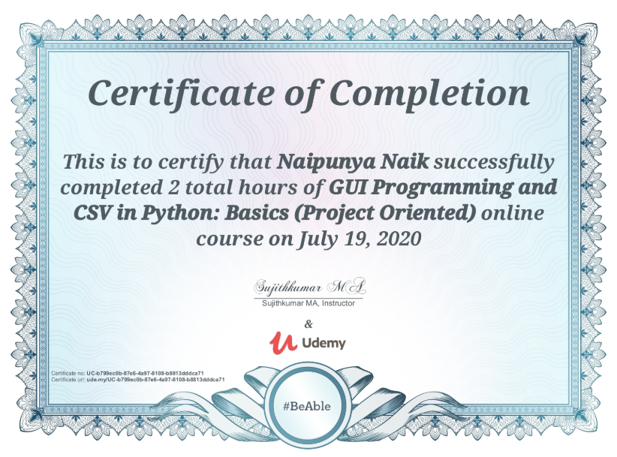

3) CERTIFICATION COURSE NAME:- **LEARN AND UNDERSTAND BUFFER OVERFLOW FROM SCRATCH –BEGINNER.**

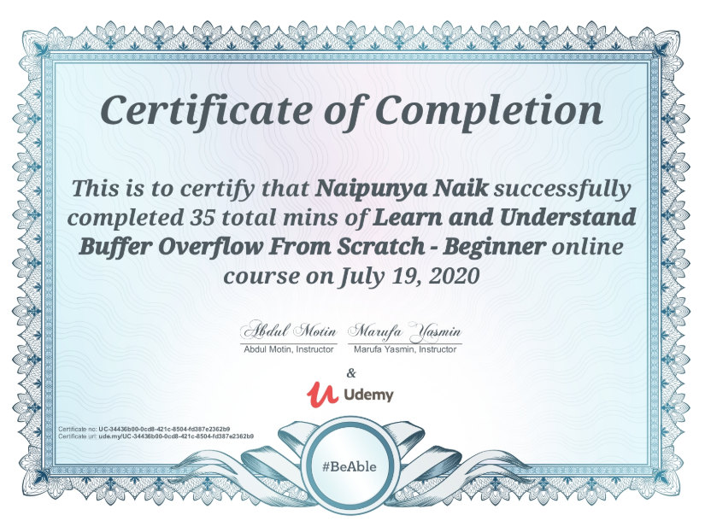

4) CERTIFICATION COURSE NAME:- **GOOGLE CLOUD PLATFORM BIG DATA AND MACHINE LEARNING FUNDAMENTALS.**

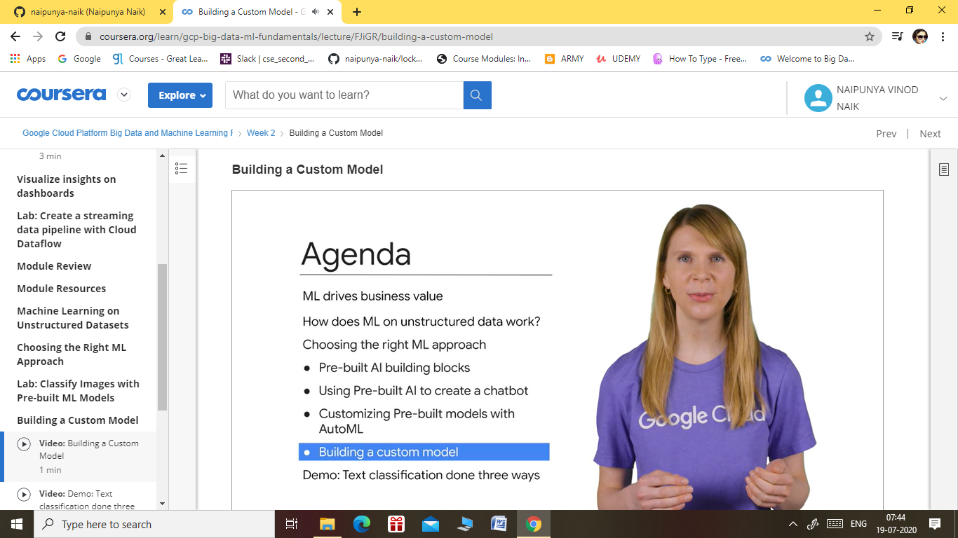

Coding Challenges Details: (Attach the snapshot and briefly write the report for the same).

PROBLEM STATEMENT:- Given two strings s1 and s2, write a snippet to check whether s2 is a rotation of s1. Strings may contain duplicates. Write a java program to check for string

rotation.

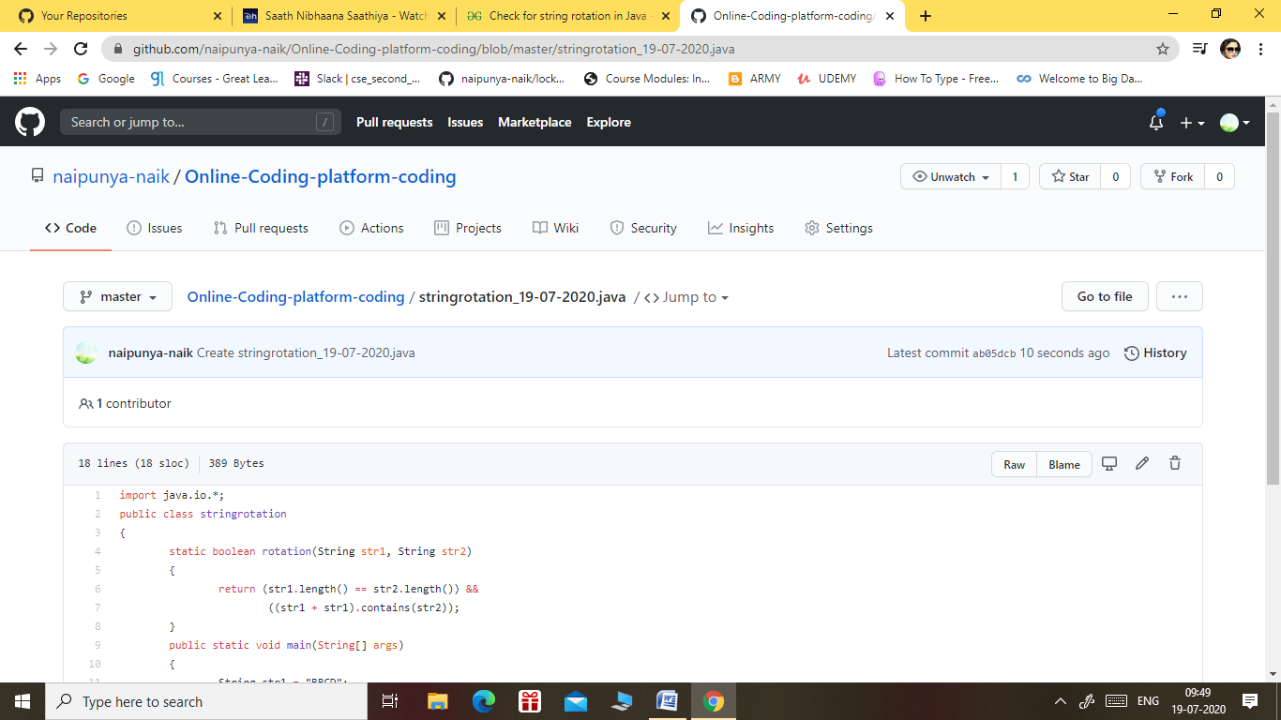

GITHUB REPOSITORY LINK:-

<https://github.com/naipunya-naik/Online-Coding-platform-coding/blob/master/stringrotation_19-07-2020.java>